# Get Team Names with a Subquery (Home and Away Teams)

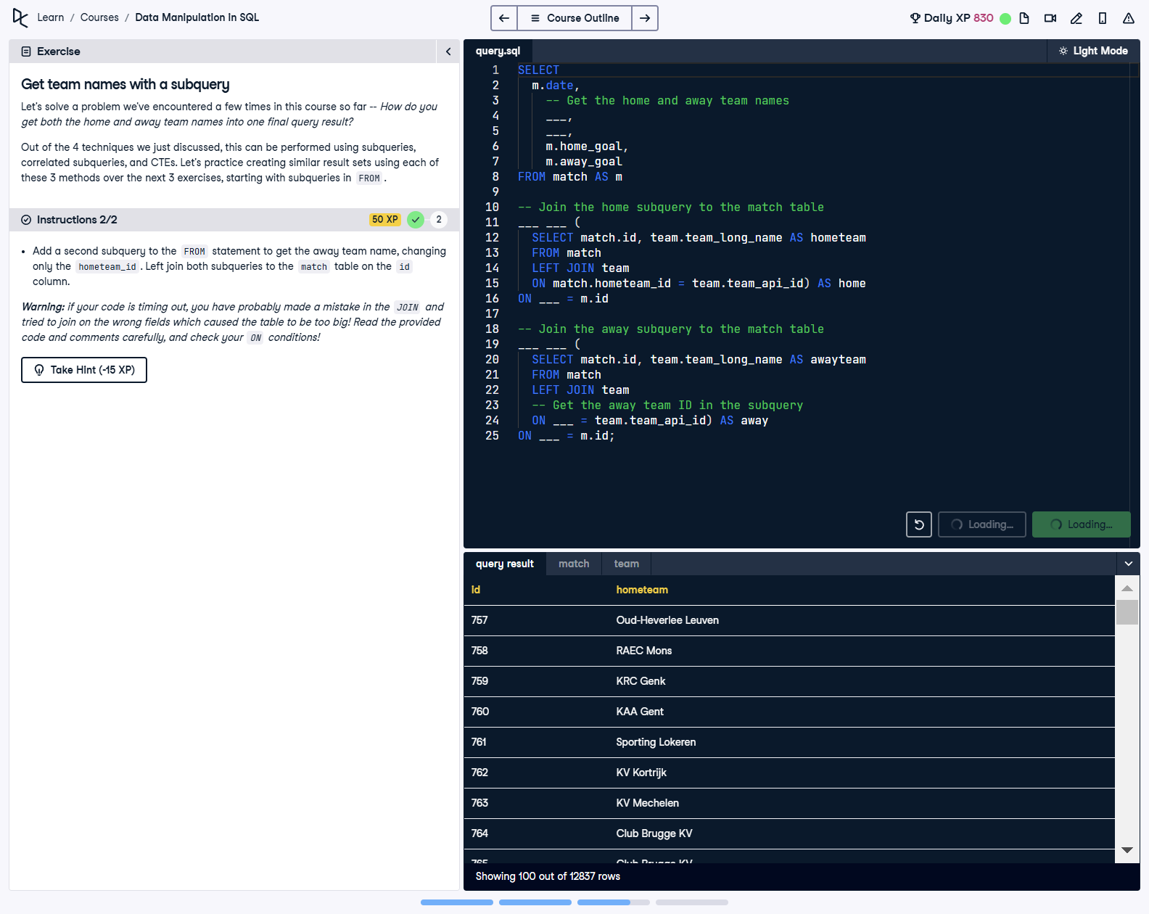

## Question

1. Add a second subquery to the FROM statement to get the away team name, changing only the hometeam_id.  
  
2. Left join both subqueries to the match table on the id column.

## Corrected Solution

SELECT  
 m.date,  
 -- Get the home and away team names  
 home.hometeam,  
 away.awayteam,  
 m.home_goal,  
 m.away_goal  
FROM match AS m  
-- Join the home subquery to the match table  
LEFT JOIN (  
 SELECT match.id, team.team_long_name AS hometeam  
 FROM match  
 LEFT JOIN team  
 ON match.hometeam_id = team.team_api_id  
) AS home  
ON home.id = m.id  
-- Join the away subquery to the match table  
LEFT JOIN (  
 SELECT match.id, team.team_long_name AS awayteam  
 FROM match  
 LEFT JOIN team  
 ON match.awayteam_id = team.team_api_id  
) AS away  
ON away.id = m.id;

## Explanation

This query retrieves match details including the date, home team name, away team name, and respective goals. Two subqueries are used to retrieve the home and away team names by joining the match table with the team table. The results of these subqueries are then joined to the match table in the main query, linking the team names to the respective matches. This ensures all required data is organized and available for further analysis.